**Scenario:**

Imagine an advanced e-commerce platform handling a diverse range of products and services. The platform caters to a large customer base, each with unique preferences and purchasing behaviors. Customers browse through various product categories, add items to their carts, and proceed to checkout to place orders. Once an order is placed, it goes through multiple stages of processing, including order confirmation, payment verification, product packaging, and shipment.

**Problem:**

In such a complex e-commerce ecosystem, efficiently managing order processing tasks poses a significant challenge. With a diverse range of products and services, each order may require different processing steps and timelines. As the platform scales and handles a larger customer base, ensuring timely and error-free order processing becomes increasingly crucial. Traditional synchronous processing methods may lead to bottlenecks and delays, impacting customer satisfaction and overall business operations.

**Solution:**

To address these challenges, we introduce a sophisticated order processing system leveraging the Behavioural Synchronization pattern. This pattern allows for asynchronous execution of order processing tasks, enabling efficient utilization of resources and handling of varying processing times. The system comprises several components:

1. Order Class: Represents an order placed by a customer, containing essential details such as order ID, customer information, and total price.

2. OrderProcessingTask Interface: Defines a set of tasks related to order processing, such as order confirmation, payment verification, product packaging, and shipment.

3. Concrete Task Implementations: Concrete classes implementing the OrderProcessingTask interface, each representing a specific processing task (e.g., OrderConfirmationTask, PaymentVerificationTask, ShipmentTask).

4. BehaviouralSynchronizer Interface: Provides a contract for executing order processing tasks asynchronously.

5. DistributedBehaviouralSynchronizer Class: A concrete implementation of the BehaviouralSynchronizer interface, utilizing a distributed thread pool to manage the execution of order processing tasks efficiently.

6. Customer Class: Represents a customer interacting with the e-commerce platform. Each customer can place multiple orders, initiating the order processing workflow.

7. ECommerceSystem Class: The main application entry point orchestrating the interactions between customers, orders, and the order processing system.

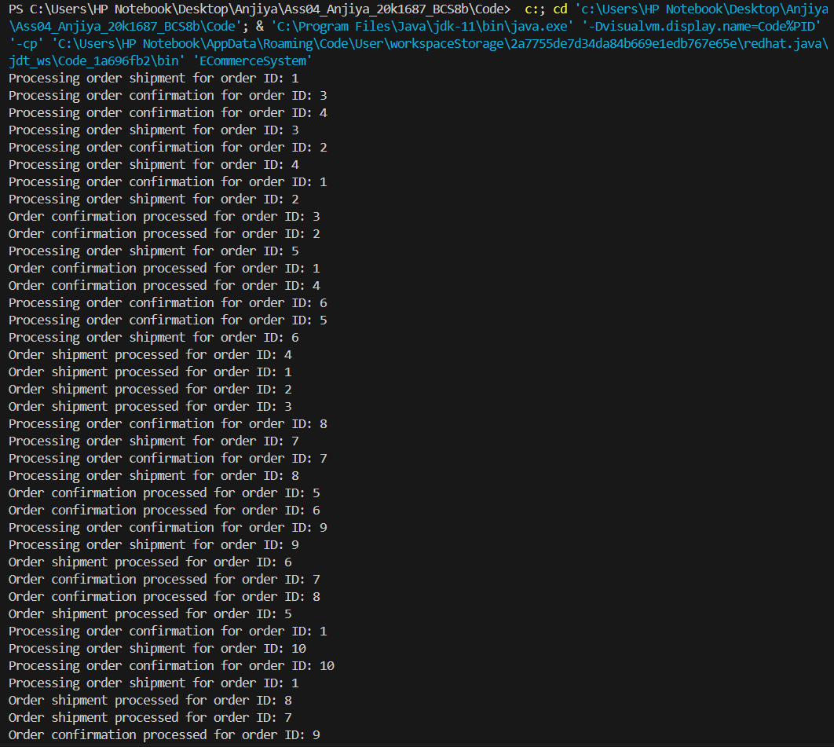**Output:**

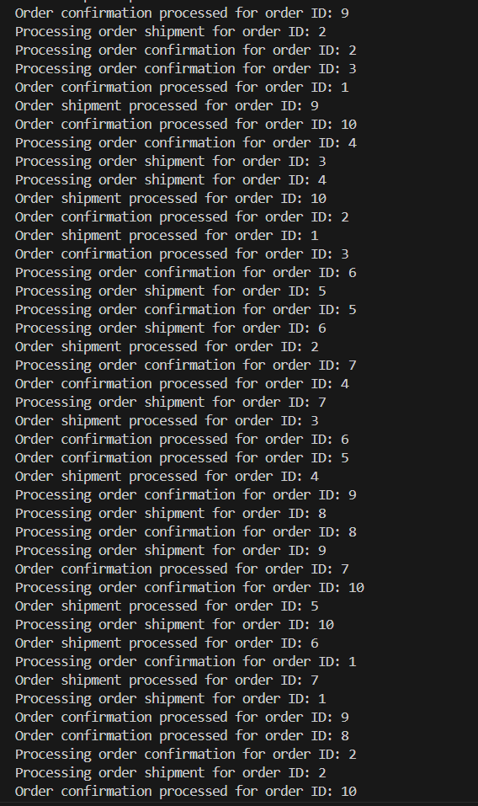  
  
  
  
  
  
  
  
  
  
  
  
  
  
  
  
  
  
  
  
  
  
  
  
  
  
  
  
  
  
  
  
  
  
  
  
  
  
  
  
  
  
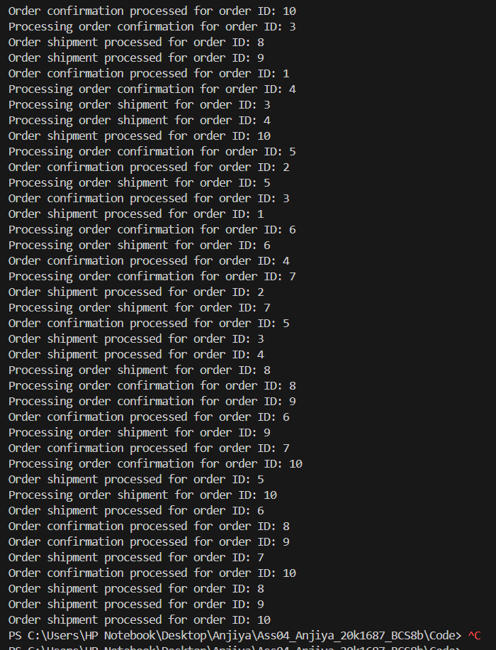

**Analysis:**

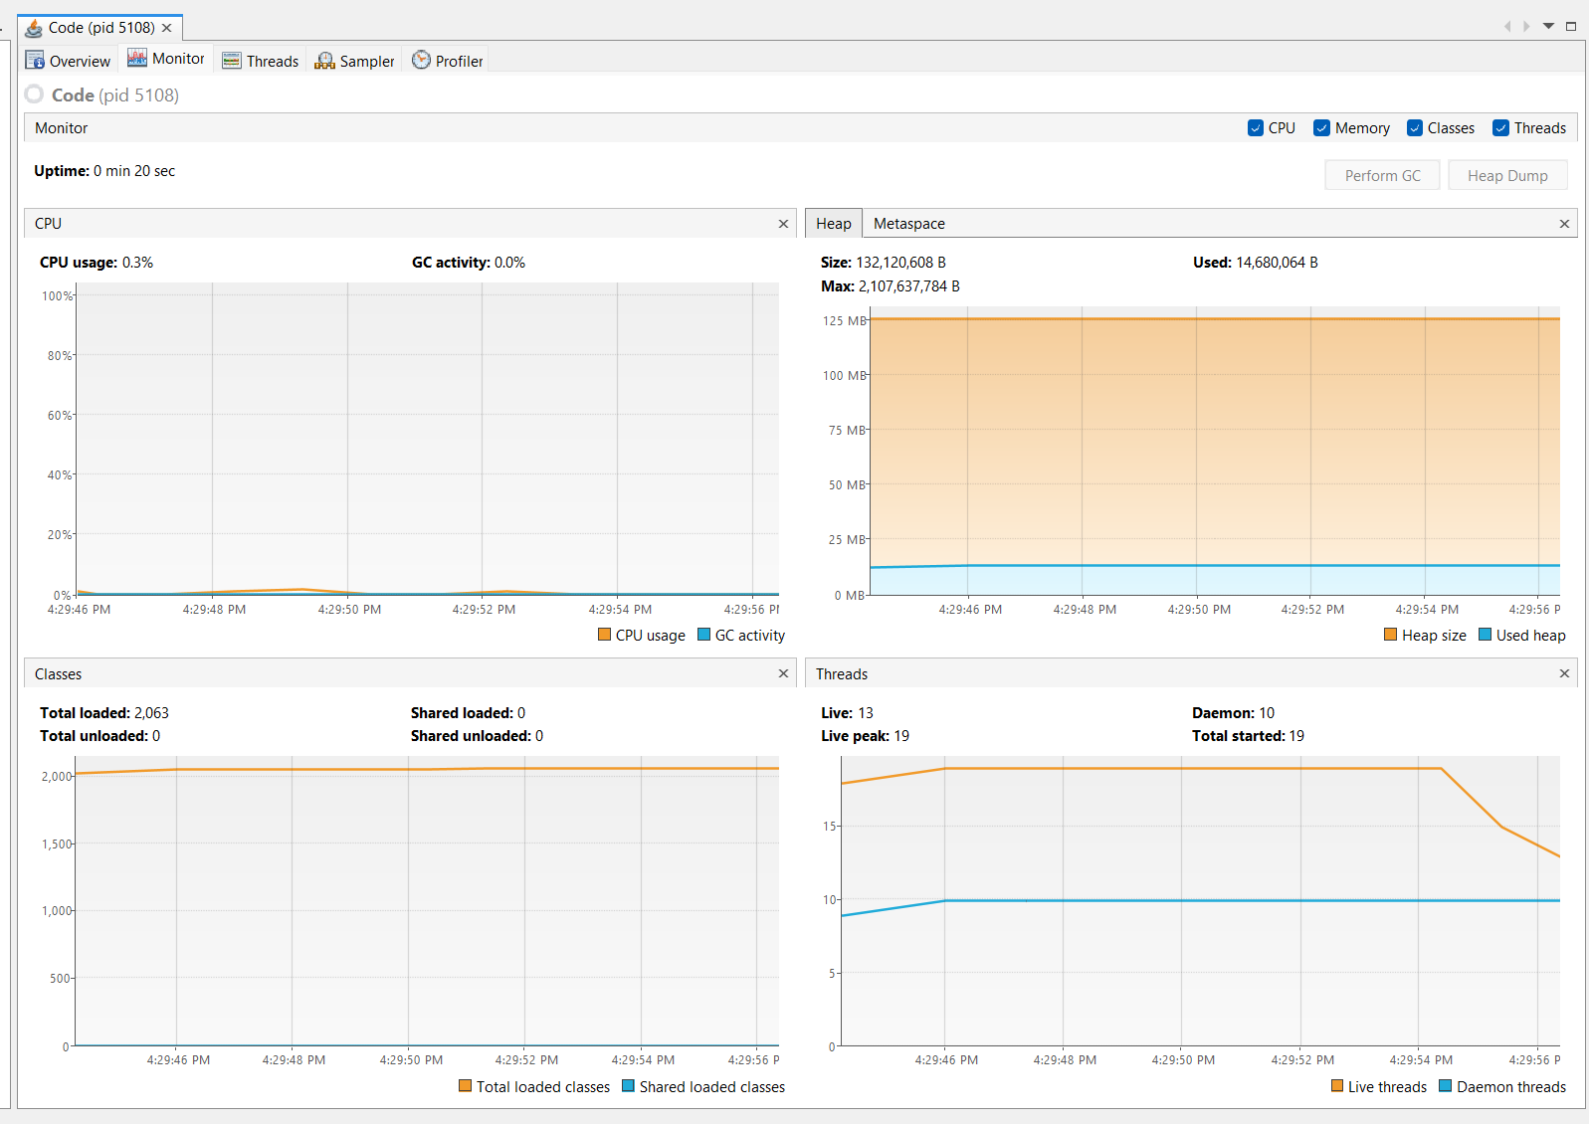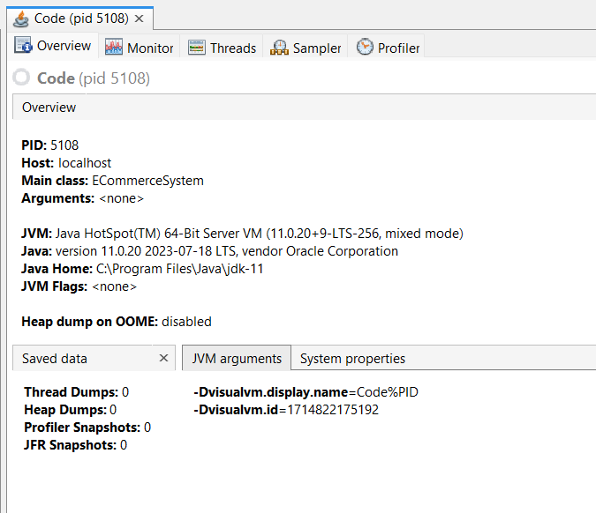  
  
  
  
  
  
  
  
  
  
  
  
  
  
  
  
  
  
  
  
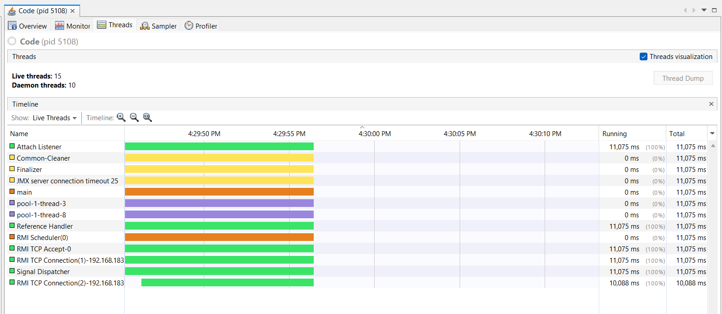  
  
**Class Diagram:**  
  
